**Course ___Methods_Test 2_ Year __12_______**

Student name: ________________ Teacher name: ________________

Date: 30 March

**Task type: Response**

**Time allowed for this task: _____45______ mins**

**Number of questions: _____9______**

**Materials required:** Calculator with CAS capability (to be provided by the student)

Standard items: Pens (blue/black preferred), pencils (including coloured), sharpener, correction fluid/tape, eraser, ruler, highlighters

Special items: Drawing instruments, templates, notes on one unfolded sheet of   
A4 paper, and up to three calculators approved for use in the WACE examinations

**Marks available: __46____ marks**

**Task weighting: __10__%**

**Formula sheet provided: Yes**

**Note: All part questions worth more than 2 marks require working to obtain full marks.**

Q1 (3.2.1-3.2.3) (3 & 3 = 6 marks)

Determine  in terms of  for the following.

1.  given that  when .

|  |
| --- |
| **Solution** |
|  |
| **Specific behaviours** |
| 🗸 uses negative indices  🗸 anti-differentiates  🗸solves for constant |

1.  given that  when .

|  |
| --- |
| **Solution** |
|  |
| **Specific behaviours** |
| 🗸 recognises that numerator is proportional to derivative of brackets  🗸 solves for multiplier constant  🗸solves for added constant, accept approx |

Q2 (3.2.21-3.2.22) (4 marks)

A particle travels along a straight line such that its acceleration at time  seconds is equal to . When the displacement is 22 metres and when 

The displacement is -10 metres. Determine the displacement when .

|  |
| --- |
| **Solution** |
|  |
| **Specific behaviours** |
| 🗸 determines velocity function  🗸 determines displacement function with two constants  🗸 solves for both constants  🗸determines displacement at t=6 |

Q3 (3.2.10-3.2.11) (2. 2, 1 & 2 = 7 marks)

Consider the function  which is graphed for .

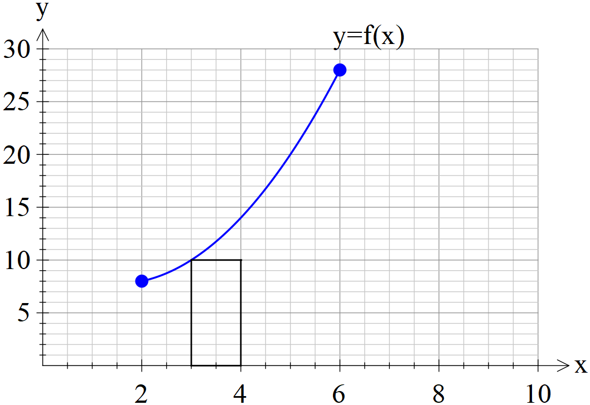

1. By using rectangles of width one unit, as shown above, determine a lower estimate for the area under  for .

|  |
| --- |
| **Solution** |
| accept(50 to 54) |
| **Specific behaviours** |
| 🗸 uses y intercepts from the left of each rectangle  🗸 determines sum of areas |

1. By using rectangles of width one unit, as shown above, determine an upper estimate for the area under  for .

|  |
| --- |
| **Solution** |
| accept (70 to 75) |
| **Specific behaviours** |
| 🗸 uses y intercepts from the right of each rectangle  🗸 determines sum of areas |

1. Determine a better approximation for the area under  for .

|  |
| --- |
| **Solution** |
|  |
| **Specific behaviours** |
| 🗸 determines average |

1. Describe two different methods to improve the approximation for the area under  for .

|  |
| --- |
| **Solution** |
| Use rectangles of smaller widths  Use calculus with an accurate rule for function  Model parabolas for the top of each rectangle and then integrate  (Note: Trapezium method is the same as averaging upper & lower rectangles therefore do NOT accept) |
| **Specific behaviours** |
| 🗸 at least one appropriate method  🗸 at least two appropriate methods |

Q4 (3.2.18-3.2.17) (3 & 2 = 5 marks)

An oil tank is drained of oil such that if  of oil in the tank  seconds after draining commences is described by .

The initially full tank is emptied in 2 mins.

1. How much oil was in the full tank? (nearest kL)

|  |
| --- |
| **Solution** |
| 27599 KL |
| **Specific behaviours** |
| 🗸 uses an integral OR anti-differentiates using 0 to 120 seconds  🗸 determines change  🗸 rounds change to nearest KL (no need to state units) |

1. How much oil was drained from the tank in the fifth second, nearest kL.

|  |
| --- |
| **Solution** |
| 230 KL |
| **Specific behaviours** |
| 🗸 sets up integral with correct limits OR uses antiderivative with correct limits  🗸 states units with answer ( no need for nearest KL) |

Q5 (3.2.11-3.2.14) (2, 2 & 2 = 6 marks)

Consider a function  which is only defined for  with



It is known that  for  and  for .

Determine.

1. 

|  |
| --- |
| **Solution** |
|  |
| **Specific behaviours** |
| 🗸 uses fundamental theorem  🗸 evaluates integral |

1. 

|  |
| --- |
| **Solution** |
|  |
| **Specific behaviours** |
| 🗸 uses linearity principle  🗸 solves for required integral |

1. The area between  and the x axes for .

|  |
| --- |
| **Solution** |
| Area= 22 + 65=87 sq units |
| **Specific behaviours** |
| 🗸 uses absolute value of each integral  🗸 determines area |

Q6 (3.2.20) (4 marks)

Determine to two decimal places the area between the curves  and .

(Hint- Sketch the curves first on your classpad)

|  |
| --- |
| **Solution** |
| Area = 5.01 sq units |
| **Specific behaviours** |
| 🗸 determines points of intersection  🗸 uses integral with difference between functions OR sets up integral from  🗸 uses integrals with absolute values  🗸determines area no need to round to 2 dp |

Q7 (3.2.16) (2 & 2 = 4 marks)

Consider 

Determine.

1. 

|  |
| --- |
| **Solution** |
|  |
| **Specific behaviours** |
| 🗸 uses fundamental theorem  🗸 determines derivative in terms of x |

1. 

|  |
| --- |
| **Solution** |
|  |
| **Specific behaviours** |
| 🗸 uses chain rule correctly  🗸 determines derivative |

Q8 (3.1.4) (4 marks)

The instantaneous rate of decline in the number of kangaroos on a particular park is 30% of the population per year. If there were 12 050 kangaroos on the park 3 years ago, how many will be on the park in four years from now

|  |
| --- |
| **Solution** |
|  |
| **Specific behaviours** |
| 🗸 recognizes exponential decay  🗸 uses correct model of rule  🗸 uses correct parameters (both)  🗸determines final population ( no need to round) |

Q9 (3.2.6) (6 marks)

1. Determine .

|  |
| --- |
| **Solution** |
|  |
| **Specific behaviours** |
| 🗸 uses product rule correctly  🗸 determines derivative |

1. Using your result from part (a) and without using your classpad determine 

|  |
| --- |
| **Solution** |
|  |
| **Specific behaviours** |
| 🗸 Uses linearity of antidifferentiation  🗸 uses Fundamental Theorem of Calculus  🗸integrates (x+1)1/3 term correctly  🗸Determines integral with a constant |